 | 

IOT BASED SMART HEALTH TRACKING AND AIR PURIFYING SYSTEM FOR HAZARDOUS ENVIRONMENT MONITORING

A MINI PROJECT REPORT

Submitted by

732923ECR144 |  | SRI PAAL R
732923ECR148 |  | SRINITHI M
732923ECR155 |  | SUGANTH A

in partial fulfillment for the award of the degree
of
BACHELOR OF ENGINEERING
in
ELECTRONICS AND COMMUNICATION ENGINEERING

VELALAR COLLEGE OF ENGINEERING AND TECHNOLOGY, ERODE-638012

MAY 2026
VELALAR COLLEGE OF ENGINEERING AND TECHNOLOGY
(An Autonomous Institution Affiliated to Anna University, Chennai)
ERODE-638012

BONAFIDE CERTIFICATE

Certified that a Mini Project report “ IOT BASED SMART HEALTH TRACKING AND AIR PURIFYING SYSTEM FOR HAZARDOUS ENVIRONMENT MONITORING ” is the bonafide work of
“ SRI PAAL R. (732923ECR144), SRINITHI M. (732923ECR148) and SUGANTH A. (732923ECR155) ” who carried out the mini project under my supervision. Certified further that to the best of my knowledge the work reported herein does not form part of any other thesis or dissertation on the basis of which a degree or award was conferred on an earlier occasion on this or any other candidate.

Ms. R. INDHUMATHI B.E., M.E., | Dr.M.NISHA ANGELINE B.E., M.E., Ph.D.,
SUPERVISOR | HEAD OF THE DEPARTMENT
Assistant Professor | Professor
Department of ECE | Department of ECE
Velalar College of Engineering and Technology | Velalar College of Engineering and Technology
Thindal, Erode - 638012. | Thindal, Erode - 638012.

Submitted for Semester Mini Project viva-voce examination held on

INTERNAL EXAMINER | EXTERNAL EXAMINER

ACKNOWLEDGEMENT

We have the privilege to express our heartfelt
thanks to our honorable Secretary and Correspondent
Thiru. S. D. CHANDRASEKAR B.A., who provides all facilities to build this mini project.

We express our deep sense of gratitude and sincere thanks to our Principal Dr. M. JAYARAMAN B.E., M.E., Ph.D., for permitting us to undertake this mini project.

We are indeed grateful to our Dean
Prof. P. JAYACHANDAR M.E., for giving us the opportunity and continuous inspiration to carry out this mini project.

We express our profound gratitude to our beloved Controller of Examinations Dr. K. R. VALLUVAN B.Tech., M.E., Ph.D., and Head of the Department Dr. M. NISHA ANGELINE B.E., M.E., Ph.D., for their valuable guidance, support and immensely profited by their comments and reviews.

We express our sincere thanks to our mini project coordinator
Dr. S. RAJAN B.E., M.E., Ph.D., Professor and mini project supervisor Ms. R. INDHUMATHI B.E., M.E., Assistant Professor for their valuable guidance to do our mini project successfully.

We are greatly indebted to many people who have contributed to the progress of our mini project.

ABSTRACT
Industrial workers often face hazardous environmental conditions such as harmful gases, dust, and poor air quality, especially in industries like mining, construction, and chemical processing. Continuous exposure to such conditions can lead to serious health problems, including respiratory issues and reduced oxygen levels. Although safety equipment is commonly used, many existing solutions provide only partial protection. Therefore, there is a need for a smart and reliable system that ensures both protection and continuous monitoring of worker safety.
To address this challenge, the proposed system presents an IoT-based air-purifying and health monitoring solution for hazardous environments. The system uses advanced filtration methods to remove dust, smoke, and harmful gases, ensuring cleaner and safer air for workers. It also monitors environmental parameters such as air quality, temperature, and humidity, along with health indicators like pulse rate and oxygen saturation. The collected data is processed in real time, and any abnormal condition triggers an immediate alert to warn the user. The system is designed to be compact, energy-efficient, and suitable for continuous use in industrial settings. It ensures the timely detection of dangerous gas levels before they reach critical limits. The system also reduces the dependency on manual monitoring, minimizing human error in safety supervision. Battery backup support is included to maintain uninterrupted operation in remote areas. Additionally, the integration of smart sensors improves overall system reliability and performance accuracy.
In addition to local alerts, the system enables remote monitoring through an IoT platform, allowing supervisors to track worker conditions in real time. The data is transmitted wirelessly and displayed on user-friendly interfaces for easy access and analysis, improving response time during emergencies and enhancing overall safety management. It also supports data logging for future analysis and helps in identifying patterns in hazardous conditions. The system can be further expanded for large-scale industrial safety applications. The IoT dashboard provides real-time visualization of sensor data, making decision-making faster and more efficient. Alerts can also be sent through mobile notifications or cloud platforms for immediate action. This improves coordination between workers and supervisors during emergency situations. By integrating air purification, health monitoring, and IoT technology, the proposed system provides an effective and practical solution for improving worker safety in hazardous industrial environments, achieving an accuracy of approximately 95%.
TABLE OF CONTENTS

CHAPTER  NO. | TITLE |  |  |  |  |  |  |  |  |  |  | PAGE  NO.
 | ABSTRACT |  |  |  |  |  |  |  |  |  |  | iv
 | LIST OF TABLES |  |  |  |  |  |  |  |  |  |  | viii
 | LIST OF FIGURES |  |  |  |  |  |  |  |  |  |  | ix
 | LIST OF ABBREVIATIONS |  |  |  |  |  |  |  |  |  |  | x
1 | INTRODUCTION |  |  |  |  |  |  |  |  |  |  | 1
 | 1.1 |  |  |  |  |  |  | INTERNET OF THINGS |  |  |  | 1
 | 1.2 |  |  |  |  |  |  | IOT IN INDUSTRIAL SAFETY |  |  |  | 2
 |  |  |  |  |  |  |  | 1.2.1 | Air Purification in Hazardous Environments |  |  | 2
 |  |  |  |  |  |  |  | 1.2.2 | Health Monitoring for Industrial Workers |  |  | 2
 | 1.3 |  |  |  |  |  |  | APPLICATIONS |  |  |  | 3
2 | PROBLEM FORMULATION |  |  |  |  |  |  |  |  |  |  | 4
 | 2.1 |  |  |  |  |  | NEED FOR THE PROPOSED SYSTEM |  |  |  |  | 4
 | 2.2 |  |  |  |  |  | LITERATURE SURVEY |  |  |  |  | 5
3 | PROPOSED SYSTEM |  |  |  |  |  |  |  |  |  |  | 8
 | 3.1 |  |  |  |  | INTRODUCTION |  |  |  |  |  | 8
 | 3.2 |  |  |  |  | BLOCK DIAGRAM |  |  |  |  |  | 9
 | 3.3 |  |  |  |  | DESCRIPTION |  |  |  |  |  | 9
 | 3.4 |  |  |  |  | ADVANTAGES |  |  |  |  |  | 10
 | 3.5 |  |  |  |  | HARDWARE DESCRIPTION |  |  |  |  |  | 11
 |  |  |  |  |  | 3.5.1 |  |  | ESP32 Module |  |  | 11
 |  |  |  |  |  |  |  |  | 3.5.1.1 |  | General Description | 11
 |  |  |  |  |  |  |  |  | 3.5.1.2 |  | Technical Specifications | 12
 |  |  |  |  |  |  |  |  | 3.5.1.3 |  | Key Features | 13
 |  |  |  |  |  |  |  |  | 3.5.1.4 |  | Advantages | 13
 |  |  |  |  |  | 3.5.2 |  |  | MQ7 Carbon Monoxide Sensor |  |  | 13
 |  |  |  |  |  |  |  |  | 3.5.2.1 |  | General Description | 13
 |  |  |  |  |  |  |  |  | 3.5.2.2 |  | Key Features | 14
 |  |  |  |  |  |  |  |  | 3.5.2.3 |  | Advantages | 14
 |  |  |  |  |  | 3.5.3 |  |  | MQ135 Air Quality Sensor |  |  | 15
 |  |  |  |  |  |  |  |  | 3.5.3.1 |  | General Description | 15
 |  |  |  |  |  |  |  |  | 3.5.3.2 |  | Key Features | 16
 |  |  |  |  |  |  |  |  | 3.5.3.3 |  | Advantages | 16
 |  |  |  |  | 3.5.4 |  |  |  | DHT11 Sensor |  |  | 16
 |  |  |  |  |  |  |  |  | 3.5.4.1 |  | General Description | 16
 |  |  |  |  |  |  |  |  | 3.5.4.2 |  | Key Features | 17
 |  |  |  |  |  |  |  |  | 3.5.4.3 |  | Advantages | 17
 |  |  |  |  | 3.5.5 |  |  |  | MAX30100 Pulse Oximeter Sensor |  |  | 18
 |  |  |  |  |  |  |  |  | 3.5.5.1 |  | General Description | 18
 |  |  |  |  |  |  |  |  | 3.5.5.2 |  | Key Features | 18
 |  |  |  |  |  |  |  |  | 3.5.5.3 |  | Advantages | 18
 |  |  |  |  | 3.5.6 |  |  |  | HEPA Filter Sheet |  |  | 19
 |  |  |  |  |  |  |  |  | 3.5.6.1 |  | Features | 19
 |  |  |  |  |  |  |  |  | 3.5.6.2 |  | Advantages | 19
 |  |  |  |  | 3.5.7 |  |  |  | Activated Carbon Filter Sheet |  |  | 19
 |  |  |  |  |  |  |  |  | 3.5.7.1 |  | Features | 19
 |  |  |  |  |  |  |  |  | 3.5.7.2 |  | Advantages | 20
 |  |  |  |  | 3.5.8 |  |  |  | LCD Display |  |  | 20
 |  |  |  |  |  |  |  |  | 3.5.8.1 |  | Features | 20
 |  |  |  |  |  |  |  |  | 3.5.8.2 |  | Advantages | 20
 |  |  |  |  | 3.5.9 |  |  |  | Buzzer |  |  | 21
 |  |  |  |  |  |  |  |  | 3.5.9.1 |  | Features | 21
 |  |  |  |  |  |  |  |  | 3.5.9.2 |  | Advantages | 21
 |  |  |  |  | 3.5.10 |  |  |  | BC547 Transistor |  |  | 22
 |  |  |  |  |  |  |  |  | 3.5.10.1 |  | Features | 22
 |  |  |  |  |  |  |  |  | 3.5.10.2 |  | Advantages | 22
 | 3.6 |  |  |  | SOFTWARE DESCRIPTION |  |  |  |  |  |  | 23
 |  |  |  |  | 3.6.1 |  |  |  | Arduino IDE |  |  | 23
 |  |  |  |  | 3.6.2 |  |  |  | Blynk IoT platform |  |  | 23
 |  |  |  |  | 3.6.3 |  |  |  | Wi-Fi Communication Using ESP32 |  |  | 23
4 | RESULTS AND DISCUSSION |  |  |  |  |  |  |  |  |  |  | 25
 | 4.1 | RESULTS |  |  |  |  |  |  |  |  |  | 25
 |  | 4.1.1 |  |  |  |  |  |  |  | Hardware Performance |  | 25
 |  | 4.1.2 |  |  |  |  |  |  |  | IoT Monitoring Interface |  | 29
 | 4.2 | DISCUSSION |  |  |  |  |  |  |  |  |  | 29
 |  | 4.2.1 |  |  |  |  |  |  |  | System Analysis |  | 29
 |  |  | 4.2.2 |  |  |  |  |  |  | Sensor Response |  | 30
 |  |  | 4.2.3 |  |  |  |  |  |  | Worker Safety Improvement |  | 30
5 | CONCLUSION AND FUTURE SCOPE |  |  |  |  |  |  |  |  |  |  | 31
 | 5.1 |  |  | CONCLUSION |  |  |  |  |  |  |  | 31
 | 5.2 |  |  | FUTURE SCOPE |  |  |  |  |  |  |  | 31
 | APPENDIX |  |  |  |  |  |  |  |  |  |  | 32
 | REFERENCES |  |  |  |  |  |  |  |  |  |  | 42

LIST OF TABLES

TABLE  NO. | TITLE | PAGE  NO.
4.1 | Sensor Threshold Analysis | 28
4.2 | Overall System Performance Analysis | 30

LIST OF FIGURES

FIGURE  NO. | FIGURE NAME | PAGE  NO.
3.1 | Block Diagram of the Proposed System | 9
3.2 | ESP32 Module | 12
3.3 | MQ7 Carbon Monoxide Sensor | 14
3.4 | MQ135 Air Quality Sensor | 15
3.5 | DHT11 Sensor | 17
3.6 | MAX30100 Pulse Oximeter Sensor | 18
3.7 | HEPA Filter Sheet | 19
3.8 | Activated Carbon Filter Sheet | 20
3.9 | LCD Display | 21
3.10 | Buzzer | 21
3.11 | BC547 Transistor | 22
4.1 | Hardware Module of the Proposed System | 25
4.2 | Air Quality Monitoring | 26
4.3 | Temperature and Humidity Monitoring | 27
4.4 | Heart Rate Monitoring | 27
4.5 | Alert System Monitoring | 28
4.6 | Software Interface of Proposed System | 29

LIST OF ABBREVIATIONS

ADC | Analog to Digital Converter
BLE | Bluetooth Low Energy
BPM | Beats Per Minute
CAN | Controller Area Network
CH₄ | Methane
CO | Carbon Monoxide
CO₂ | Carbon Dioxide
CPU | Central Processing Unit
CSI | Camera Serial Interface
DHT11 | Digital Humidity and Temperature Sensor
DSI | Display Serial Interface
ESP32 | Espressif 32-bit Microcontroller
ESP-NOW | Espressif Wireless Communication Protocol
GPIO | General Purpose Input Output
GPU | Graphics Processing Unit
H₂S | Hydrogen Sulfide
HEPA | High-Efficiency Particulate Air
I²C | Inter-Integrated Circuit Communication Protocol
I²S | Integrated Interchip Sound
IoT | Internet of Things
LCD | Liquid Crystal Display
LED | Light Emitting Diode
MAX30100 | Pulse Oximeter and Heart Rate Sensor Module
MPPS | Most Penetrating Particle Size
MQ135 | Air Quality Gas Sensor
MQ7 | Carbon Monoxide Gas Sensor
MQTT | Message Queuing Telemetry Transport
NDIR | Non-Dispersive Infrared
NH₃ | Ammonia
NOx | Nitrogen Oxides
PCB | Printed Circuit Board
PPG | Photoplethysmography
PPM | Parts Per Million
PWM | Pulse Width Modulation
SCL | Serial Clock Line
SDA | Serial Data Line
SPI | Serial Peripheral Interface
SPO₂ | Peripheral Capillary Oxygen Saturation
TCP | Transmission Control Protocol
UART | Universal Asynchronous Receiver Transmitter
UDP | User Datagram Protocol
VOCs | Volatile Organic Compounds
Wi-Fi | Wireless Fidelity
WLAN | Wireless Local Area Network
WSN | Wireless Sensor Network

CHAPTER 1
INTRODUCTION

INTERNET OF THINGS
The Internet of Things (IoT) is a network of interconnected physical devices that are capable of collecting, exchanging, and processing data through the internet with minimal human intervention. These devices are embedded with sensors, communication modules, and processing units, enabling them to interact intelligently with their environment. IoT systems allow seamless communication between devices and users, leading to the development of smarter and more responsive systems that can adapt to changing conditions. The rapid growth of IoT is mainly driven by advancements in wireless communication technologies, cloud computing, and data analytics. In addition, the availability of low-cost smart devices and reliable internet connectivity hnas made it possible to connect a wide range of systems and monitor them in real time. This improved connectivity supports efficient data collection and analysis, which helps in faster decision-making and enhances overall system performance across various domains.
IoT technology is widely applied in fields such as healthcare, transportation, smart homes, and industrial automation. In industrial environments, it plays a crucial role in monitoring environmental conditions, detecting abnormalities, and improving worker safety through real-time alerts and control systems. This leads to increased productivity, reduced downtime, and improved operational reliability, while also supporting predictive maintenance. A typical IoT system consists of data collection, processing, communication, and user interaction layers, where data is transmitted to cloud platforms for storage and analysis. Users can access this information remotely through mobile or web applications, enabling real-time monitoring and quick decision-making from any location. Although IoT offers significant advantages such as automation, efficiency, and enhanced safety, it also faces challenges related to data security and privacy. Despite these limitations, IoT continues to evolve as a key technology for building smart and connected systems. In addition, IoT systems support continuous monitoring without manual intervention, making them highly efficient for critical applications. They can also integrate with artificial intelligence and machine learning models to improve prediction accuracy and decision-making. The scalability of IoT allows it to be implemented in both small-scale and large-scale systems, depending on requirements. Furthermore, IoT helps in reducing operational costs by optimizing resource usage and minimizing energy consumption.

IOT IN INDUSTRIAL SAFETY
Workers in industrial settings are exposed to various risks, including exposure to gases, heat, dust, and mechanical hazards, making safety a critical concern. Internet of Things (IoT) technology enhances safety in industrial environments through real-time monitoring, data collection, and analysis. IoT devices can sense hazardous situations quickly and communicate alerts to prevent accidents and reduce risks. It also enables continuous tracking of environmental conditions such as air quality, temperature, and humidity, along with monitoring the health status of workers. In addition, IoT supports automation and smart decision-making by analyzing both real-time and historical data to identify potential risks before they occur. This predictive capability helps in preventing incidents and improving response time during emergencies. The data collected can be remotely accessed and monitored, allowing supervisors to take timely actions and ensure better safety management. Overall, IoT significantly improves workplace safety, efficiency, and reliability in industrial operations.
1.2.1 Air Purification in Hazardous Environments
In hazardous industrial environments, workers are exposed to polluted air containing toxic gases, smoke, and dust particles, which can lead to serious health issues and respiratory problems with continuous exposure. Therefore, maintaining clean and safe air is essential for ensuring worker safety and preventing long-term health complications. Air purification systems help remove harmful particles and gases from the air using advanced filtration methods such as HEPA and activated carbon filters. In this project, air purification is integrated with real-time monitoring to continuously track air quality and ensure immediate response to unsafe conditions. This combination helps in maintaining a safer and healthier working environment for industrial workers. It also reduces the risk of occupational diseases caused by prolonged exposure to polluted air. Overall, this system significantly improves workplace safety and enhances the overall quality of industrial working conditions.
1.2.2 Health Monitoring for Industrial Workers
Worker health is a key factor in ensuring safety in hazardous industrial environments. Exposure to unsafe conditions like poor air quality and low oxygen levels can cause fatigue, breathing problems, and other serious health issues. Because of this, continuous monitoring of worker health is vital for maintaining a safe working environment. In this project, the system tracks important health parameters such as pulse rate and oxygen saturation (SpO₂). When it detects abnormal values, it generates an alert to prompt immediate action. This method helps reduce health risks and provides better protection and well-being for industrial workers.

APPLICATIONS
The proposed IoT-based smart air-purifying and health monitoring system is designed for industrial environments where workers face hazardous gases, dust, and poor air quality. The system combines real-time gas detection, dual-stage filtration with HEPA and activated carbon filters, monitoring of oxygen saturation (SpO₂) and heart rate, and IoT-based alerts to improve worker safety. It is suitable for several key applications.
Chemical Processing Plants: Workers in the chemical industry are exposed to ammonia, volatile organic compounds, and other toxic gases. The system detects harmful gases, purifies air through adsorption, and provides real-time alerts during leaks. Health monitoring helps identify early signs of exposure and ensures timely action. This improves workplace safety and minimizes chemical exposure risks.
Oil and Gas Refineries: Workers in refineries face exposure to hydrogen sulfide and hydrocarbons. The system delivers reliable gas detection even when human senses fail, along with continuous monitoring of oxygen levels. IoT connectivity enables supervisors to monitor worker conditions and take immediate action. This ensures higher safety standards in high-risk environments.
Construction and Demolition Sites: Construction activities produce silica dust, smoke, and exhaust gases that can harm worker health. The system ensures effective dust filtration, real-time environmental monitoring, and health tracking. It helps prevent respiratory issues and heat-related illnesses. This makes construction sites safer and more controlled working environments.
Manufacturing and Foundry Operations: Manufacturing units expose workers to fumes, solvent vapors, and metal dust. The system provides a constant supply of purified air and supports data logging for exposure tracking.
Firefighting Operations: Firefighters are exposed to smoke, toxic gases, and low oxygen levels in hazardous environments. The system provides continuous real-time air quality monitoring, oxygen support, and health tracking. It also generates alerts during critical conditions to ensure a quick response.
Mining and Underground Operations: Workers in mining environments are exposed to methane, carbon monoxide, dust particles, and oxygen-deficient conditions. The proposed system continuously monitors hazardous gas levels and worker health parameters such as heart rate and SpO₂.

CHAPTER 2
PROBLEM FORMULATION

NEED FOR THE PROPOSED SYSTEM
Industrial workers in environments such as coal mines, chemical plants, oil refineries, construction sites, and manufacturing units are continuously exposed to hazardous airborne pollutants, including carbon monoxide, ammonia, volatile organic compounds, and fine particulate matter. Prolonged exposure to these contaminants can lead to serious health issues such as respiratory disorders and reduced blood oxygen levels. According to the World Health Organization, air pollution contributes to millions of deaths each year, highlighting the urgent need for effective safety systems in industrial environments.
Despite existing safety measures, current systems have several limitations. Most air purification systems operate at fixed speeds and are unable to adapt to sudden changes in air quality, resulting in inadequate protection during pollution spikes. Monitoring systems are generally stationary, which creates blind spots and fails to track the movement of workers across different zones. In addition, workers often rely on passive filtration masks, whose effectiveness depends heavily on proper fitting and consistent usage.
A major limitation is the lack of real-time physiological monitoring. Critical health parameters such as heart rate and blood oxygen saturation (SPO₂) are not continuously tracked in most existing systems, making it difficult to identify early signs of health distress. Furthermore, current solutions do not provide a direct supply of purified air at the breathing level, which reduces their effectiveness in highly polluted environments. In many cases, delayed detection of abnormal health conditions can lead to severe consequences. There is also no proper integration between environmental data and personal health data, which limits overall system intelligence. Continuous monitoring with instant feedback is essential for preventing emergency situations in industrial workplaces.
Therefore, there is a clear need for a wearable, IoT-based smart system that integrates environmental monitoring, active air purification, continuous health tracking, and real-time alerting. Such a system can significantly improve worker safety, reduce health risks, and provide a more reliable and intelligent solution for hazardous industrial environments. It also enhances real-time decision-making through continuous data analysis. The system enables faster emergency response and better safety management. Additionally, it supports long-term monitoring to prevent future risks and improve overall workplace efficiency.

LITERATURE SURVEY
Abro, Shaikh, Soomro, Abid, Kumar, and Ahmed (2018), in their work “Prototyping IoT-Based Smart Wearable Jacket Design for Securing the Life of Coal Miners,” present a wearable safety system designed for coal mining environments. The system integrates gas sensors, temperature sensors, and IoT modules to monitor hazardous conditions in real time. It continuously detects toxic gases and environmental parameters and transmits data to a remote monitoring system. Alerts are generated to warn workers and supervisors during dangerous situations. This improves safety through early detection and rapid response. However, the system depends on network connectivity and has higher power consumption due to continuous monitoring. [1]
Anitha and Kumar (2023), in their work “Development of an IoT-Enabled Air Pollution Monitoring and Air Purifier System,” propose a system that combines air quality monitoring with purification. The system uses sensors to detect pollutants and activate filtration mechanisms to improve air quality. Data is transmitted through IoT for real-time monitoring and analysis. Alerts are generated when pollution levels exceed safe limits. This integration enhances environmental safety and efficiency. However, the system may face limitations in scalability and maintenance of filtration units. [2]
Bandara, Minsilu, Karunarathne, and Edirisinghe (2024), in their work “Air Quality Monitoring in Industry 5.0 using Edge Computing,” present an advanced monitoring system using edge computing. The system processes sensor data locally to reduce latency and improve real-time response. It collects air quality parameters and analyzes them at the edge level. This reduces dependency on cloud processing and enhances efficiency. The approach supports faster decision-making in industrial environments. However, edge devices may have limited processing capability and increased implementation cost. [3]
Devi, Ragavan, Sharmin Smiley, Aakash, and Kumar (2025), in their work “Air Quality Monitoring and Air Filtering System Using IoT,” propose a system integrating monitoring and filtration. It uses sensors to detect harmful gases and activates filtering mechanisms automatically. Real-time data is transmitted via IoT for remote monitoring. Alerts are generated during abnormal conditions. The system improves air quality and worker safety. However, continuous operation may increase energy consumption. [4]

Gopalka, Parikh, and Shah (2025), in their work “Design and Development of an IoT-Enabled Smart Air-Purifying and Monitoring Mask for Hazardous Industrial Environments,” present a wearable system combining air purification and monitoring. The mask integrates gas sensors, a microcontroller, and IoT modules. It continuously monitors air quality and provides alerts when unsafe levels are detected. Data is transmitted for remote supervision. The design enhances worker protection and real-time awareness. However, comfort and battery life remain challenges. [5]
Herath, Jayasundara, Yadhasighe, and Sanjeewa (2022), in their work “Design and Implementation of an IoT-Based Real-Time Air Purification System,” present a system for outdoor air purification. It uses sensors to detect pollutants and activate purification mechanisms accordingly. Data is monitored in real time using IoT platforms. The system improves environmental air quality efficiently. It supports continuous monitoring and control. However, outdoor implementation may be affected by environmental variability. [6]
International Labour Organisation, Coal Mines Committee (1976), in the report “Safety and Health in Coal Mines,” provides guidelines for improving safety in coal mining environments. The report identifies major hazards such as toxic gases, dust particles, and low oxygen levels that affect worker health. It emphasizes the importance of proper ventilation systems and protective equipment to reduce risks. Regular monitoring of environmental conditions is recommended to prevent accidents and diseases. [7]
Kadarkarai, Srinivasu, Ture, Reddy, and Reddy (2025), in their work “IoT-Based Air Quality Monitoring and Air Purifier System,” propose an integrated system for monitoring and purification. It detects pollutants using sensors and activates air purification units. IoT enables real-time monitoring and alert generation. The system enhances safety and environmental quality. It is suitable for industrial applications. However, maintenance of sensors and filters is required regularly. [8]
Kanimozhi, Logesh, Prakash, and Kandasamy (2025), in their work “IoT-Enabled Air Purifiers with Real-Time Quality Monitoring,” present a smart purifier system. It continuously monitors air quality and adjusts purification levels automatically. IoT connectivity enables remote access and control. The system improves efficiency and user convenience. It provides real-time alerts and data visualization. However, system cost and energy usage can be limiting factors. [9]

Kavitha, Sasidharan, Gokul, Karthik, Latha, and Hemavathi (2024), in their work “Industry-Specific IoT-Based Air Pollution Monitoring System,” propose a monitoring system tailored for industrial environments. It uses sensors to detect pollutants specific to industries. Data is transmitted through IoT platforms for analysis. The system improves monitoring accuracy and safety. It supports real-time alerts and reporting. However, customization for different industries increases complexity.[10]
Muttaki, Afrin, Anil, and Noon (2026), in “IoT-Based Monitoring and Automated Air Purification System for Industrial Pollution Control,” developed an automated system integrating monitoring sensors and purification units. IoT enables real-time monitoring and remote control, reducing manual intervention. However, performance depends on sensor accuracy. [11]
Ramadhani, Putri, Asmarita, Amania, Mufti, Mizar, and Arrosyid (2025), in “IoT Implementation for Air Quality Monitoring System using Low Cost Sensor,” proposed a low-cost IoT-based air quality monitoring system. It supports real-time monitoring and large-scale deployment, though low-cost sensors may reduce accuracy. [12]
Vakharia and Chavan (2025), in “Development of a Compact IoT-Enabled Air Purification System for Indoor Air Quality Improvement,” designed a compact purifier with IoT-based monitoring and control. The system improves indoor air quality but is suitable only for small-scale environments. [13]
Veena, Vanathi, SadikBasha, Salma, Naveena, and Pavithra (2025), in “Real-Time Design of Coal Mine Safety Monitoring with Alerting Intelligence using IoT,” proposed a mine safety system that detects hazardous gases and provides real-time alerts through IoT. Connectivity issues underground may affect performance. [14]
Veeramanikandasamy, Raj, Balamurugan, Ramesh, and Khadar (2020), in “IoT-Based Real-Time Air Quality Monitoring and Control System,” developed an IoT-based system for industrial safety through continuous air quality monitoring and automated control using gas and particulate sensors. [15]

CHAPTER 3
PROPOSED SYSTEM

INTRODUCTION
The system is developed to address key challenges in current industrial safety systems, including the absence of real-time health monitoring, non-adaptive air purification, no IoT support, and no fixed alert system. It is designed as a smart IoT-based air-purifying worker safety system for industrial and construction sites such as coal mines, chemical plants, oil refineries, and manufacturing and construction. The system aims to enhance safety by monitoring health and the environment. It combines gas monitoring, environmental monitoring, and health parameters monitoring in one system. Real-time data analysis is applied to identify dangers in real-time. It provides timely notifications and automatic safety actions as per the severity of the situation. Environmental conditions such as toxic gases, temperature, and humidity are continuously tracked. It also monitors physiological parameters of workers, including heart rate and oxygen saturation (SPO₂). This allows the detection of environmental hazards and stress. It provides enhanced protection over conventional systems.
The system uses the ESP32 microcontroller to read and process data from all sensors. It can connect via Wi-Fi and Bluetooth for cloud and mobile apps. It also manages the alert control (buzzer, LCD, fan speed) based on sensor readings. The output of the system consists of an alarm signal (buzzer), a liquid crystal display (LCD), and fan speed control for dynamic air purification. A smart mask system with a two-stage filtration system is used for air purification. The HEPA (High-Efficiency Particulate Air) filter eliminates dust and fine particles, and the activated carbon filter absorbs toxic gases and fumes.
The sensing module is made up of several IoT sensors to measure the environment and health. The MQ135 sensor is used for NH₃, CO₂, NOx, benzene, and smoke detection. The MQ7 sensor detects carbon monoxide. The DHT11 sensor is for temperature and humidity measurements, which influence gas concentrations. The MAX30100 sensor measures heart rate and SpO₂ with photoplethysmography (PPG) to detect respiratory distress. The system is powered by a rechargeable Li-ion battery with voltage regulation. The sensor readings are sent to the Blynk IoT app for remote monitoring and storage, and to send alert notifications to supervisors if dangerous levels are reached.

BLOCK DIAGRAM
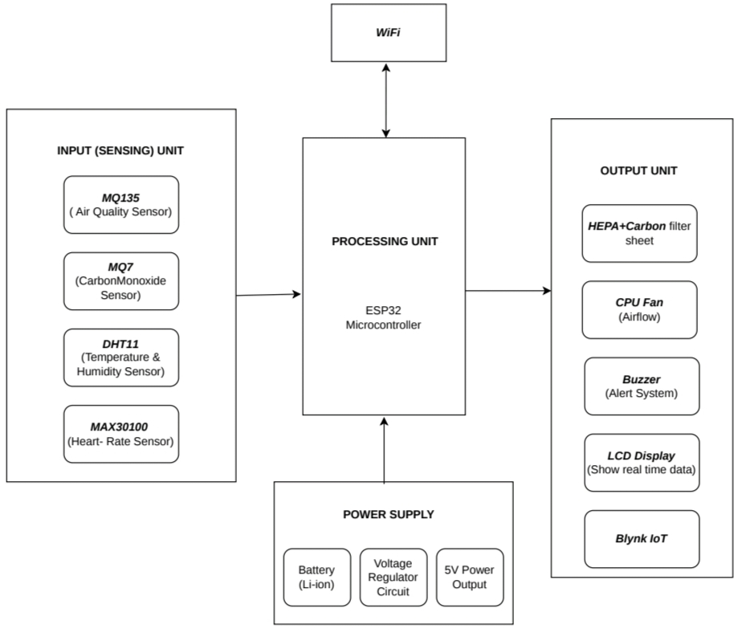
Figure 3.1 Block Diagram of the Proposed System

DESCRIPTION
The system starts operating when powered by a rechargeable Li-ion battery, while a voltage regulator provides a stable 5V supply to the ESP32 and all connected sensors, as shown in Figure 3.1. After power-on, all sensors work simultaneously, where the MQ135 sensor detects harmful gases such as NH₃, NOx, benzene, smoke, and CO₂, while the MQ7 sensor measures carbon monoxide levels in ppm. At the same time, the DHT11 sensor measures temperature and humidity, and the MAX30100 sensor monitors heart rate and SpO₂ using the PPG principle through the I²C protocol. The ESP32 continuously collects and processes all sensor data in real time by filtering noise and converting values into standard units such as ppm, °C, %, BPM, and SpO₂. The processed values are then compared with predefined safety limits, including 20 ppm for CO, 90% for SpO₂, and 60–100 BPM for normal heart rate.
The real-time sensor values are displayed on the LCD screen for local monitoring, enabling workers to easily observe air quality and health conditions. If any parameter exceeds the safety threshold, the buzzer provides an immediate warning, while the ESP32 simultaneously sends data to the Blynk IoT platform through Wi-Fi for remote monitoring and emergency alerts. The platform stores data in the cloud and allows supervisors to track worker conditions through a mobile application. During critical situations, the BC547 transistor activates the emergency oxygen support system to provide immediate assistance. In addition, the CPU fan speed is automatically adjusted according to air quality, where high pollution increases fan speed and cleaner air reduces it to conserve battery power. The HEPA filter removes fine dust particles with 99.97% efficiency at 0.3 microns, while the activated carbon filter absorbs harmful gases and chemical vapors. Thus, the entire system operates as a continuous closed-loop portable smart mask suitable for industries such as mining, factories, chemical plants, and construction sites.

ADVANTAGES
Real-Time Hazardous Gas Detection: The system continuously monitors toxic gases using the MQ135 Air Quality Sensor and MQ7 Carbon Monoxide Sensor. It detects harmful gases such as CO, NH₃, NOx, benzene, and smoke, and generates instant alerts through the buzzer, LCD, and IoT platform when safety limits are exceeded.
Continuous Worker Health Monitoring: The MAX30100 sensor continuously tracks heart rate and blood oxygen saturation (SpO₂) levels. It helps identify critical conditions such as hypoxemia (SpO₂ below 90%) and abnormal heart rate levels before they become dangerous.
Smart Air Purification System: The system uses a HEPA filter sheet and activated carbon filter sheet for air purification. The HEPA filter removes 99.97% of fine dust particles, while the activated carbon filter absorbs harmful gases and chemical vapors to provide clean breathable air.
Emergency Oxygen Support System: The emergency oxygen support system is automatically activated using a BC547 transistor when critical conditions such as high CO levels or low SpO₂ levels are detected, providing immediate respiratory assistance.
IoT-Based Remote Monitoring: The ESP32 integrated with the Blynk IoT platform enables real-time remote monitoring, cloud data storage, and instant mobile alerts. Supervisors can continuously monitor worker safety conditions and respond quickly during emergencies. The system also supports remote access to environmental and health parameters.

3.5 HARDWARE DESCRIPTION
In this section, we elaborate on the various electronic components used in the proposed system. Each component is selected to fulfill specific requirements such as sensing, processing, communication, and power management.

ESP32 Module

3.5.1.1 General Description
The ESP32 is a low-cost, low-power microcontroller developed by Espressif Systems and is widely used in IoT and embedded applications. It is well-suited for the proposed smart air-purifying worker safety system due to its built-in Wi-Fi and Bluetooth connectivity, which enable seamless data transmission without requiring additional communication modules. The dual-core processor allows efficient handling of multiple tasks such as sensor data collection, real-time monitoring, and alert generation. This makes the ESP32 a reliable and efficient choice for continuous operation in industrial environments.
The ESP32 is an advanced successor to the ESP8266, offering higher processing speed, increased memory capacity, and enhanced peripheral support. Its compact design helps reduce the overall system size, cost, and complexity, which is especially beneficial for wearable safety devices. The microcontroller also supports various interfaces such as ADC, GPIO, UART, SPI, and I2C, allowing easy integration with multiple sensors and components. These features make the ESP32 highly suitable for developing intelligent, compact, and scalable IoT-based safety systems. The ESP32 also supports low-power modes, which help extend battery life for wearable applications, provides secure data transmission with built-in encryption features, and ensures faster response and reliable performance in real-time monitoring systems due to its high processing capability.
In this system, the ESP32 acts as the main controller that manages all sensing, processing, and communication operations. It collects data from the MQ135, MQ7, DHT11, and MAX30100 sensors to monitor air quality, gas concentration, temperature, humidity, heart rate, and oxygen levels. The ESP32 processes the sensor signals and removes unwanted noise using filtering techniques to improve accuracy. It then converts the raw sensor outputs into standard units such as ppm, percentage (%), and BPM for easy analysis. The controller continuously compares all sensor readings with predefined safety threshold values to detect hazardous conditions. Based on the monitored data, it controls output devices such as the buzzer, LCD display, and CPU fan to provide alerts and ventilation support.
Additionally, the ESP32 sends real-time sensor data to the Blynk IoT platform through Wi-Fi, enabling remote monitoring and emergency response. The dual-core processor allows parallel operation, where one core handles sensor processing while the other manages wireless communication. This ensures real-time monitoring and immediate alert response, which is essential for worker safety in hazardous environments.
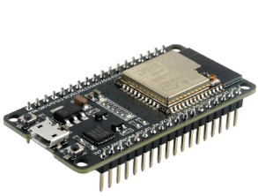

Figure 3.2 ESP32 Module

3.5.1.2 Technical Specifications
Processor: Dual-core Tensilica Xtensa LX6 32-bit processor with clock speed up to 240 MHz, providing high-speed real-time processing for IoT and embedded applications Figure 3.2 shows.
Memory: 520 KB SRAM with 4 MB integrated Flash memory, enabling efficient program storage, sensor data handling, and buffering
Wireless Communication: Wi-Fi 802.11 b/g/n (2.4 GHz) and Bluetooth v4.2 with BLE support, enabling seamless cloud connectivity and mobile application integration
GPIO Pins: 30 programmable GPIO pins used for interfacing sensors like MQ135, MQ7, DHT11, MAX30100, and controlling output devices
ADC Channels: 18-channel 12-bit ADC used for accurate reading of analog gas sensor outputs in ppm
PWM Channels: 16 PWM channels used for controlling actuators such as CPU fan speed and other control outputs
Communication Interfaces: I²C, SPI, UART, I²S, and CAN support enabling flexible multi-sensor and peripheral integration
Power Consumption: Active mode ~80 mA (Wi-Fi ON) and deep sleep ~10 µA, making it suitable for battery-powered wearable systems
Operating Temperature: -40°C to +125°C industrial range ensuring reliable performance in harsh environments
Operating Voltage: 3.0V–3.6V operating range with 5V input support via VIN/USB for stable operation

Key Features
Integrated Wi-Fi and Bluetooth: Built-in Wi-Fi (802.11 b/g/n) and Bluetooth v4.2 with BLE enable seamless wireless communication for IoT and cloud connectivity without external modules.
Dual-Core Processor Performance: The dual-core Xtensa LX6 processor allows parallel processing of sensor data and network communication, ensuring real-time system responsiveness.
Low Power Consumption: Supports deep sleep mode (as low as 10 µA), making it highly suitable for battery-powered wearable and portable industrial safety systems.
Rich Peripheral Interface Support: Includes GPIO, ADC, PWM, I²C, SPI, and UART interfaces, enabling easy integration with multiple sensors and output devices.
High Processing Speed: Operating up to 240 MHz, it efficiently handles real-time data acquisition, processing, and decision-making for multiple sensors simultaneously.

Advantages
Integrated Wireless: Built-in Wi-Fi and Bluetooth eliminate external modules, reducing cost, size, and weight.
Low Power Consumption: Deep sleep current of only 10 µA enables 24+ hours of battery life for full work shifts.
High Processing Speed: Operates up to 240 MHz for fast real-time data processing.

3.5.2 MQ7 Carbon Monoxide Sensor

3.5.2.1 General Description
In Figure 3.3, the MQ7 sensor is a gas detection module specifically designed for measuring carbon monoxide (CO) concentration in the air. It is widely used in industrial safety systems due to its ability to detect low levels of CO, which is a highly toxic and odorless gas.
This makes it highly suitable for applications where early detection of harmful gases is critical for ensuring worker safety and preventing health hazards. The sensor operates on the principle of chemiresistance, where the resistance of the sensing material changes based on the concentration of carbon monoxide present in the air. It requires a heating cycle with alternating voltages to ensure accurate measurement. In the proposed system, the MQ7 continuously monitors CO levels and sends analog signals to the ESP32, which converts them into ppm values for real-time monitoring and safety alerts.
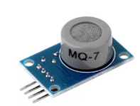
Figure 3.3 MQ7 Carbon Monoxide Sensor

3.5.2.2 Key Features
Specifically designed for carbon monoxide (CO) detection: The MQ7 sensor is optimized exclusively for CO gas sensing, providing accurate and reliable measurements in industrial environments where carbon monoxide is a primary hazard.
Detects CO in the range of 20 ppm to 2000 ppm: The sensor can measure CO concentrations from 20 parts per million (ppm) up to 2000 ppm, covering the entire spectrum from early warning levels to immediately dangerous concentrations.
Normal operating range: 0 to 10 ppm (safe condition): Under normal safe working conditions, CO levels remain between 0 and 10 ppm. The system continuously monitors to ensure levels stay within this safe range.
High sensitivity with fast response time: The sensor responds to CO presence within 10 seconds, enabling real-time detection of hazardous conditions as they develop in the workplace.

Advantages
Detects Silent and Deadly Gas: The MQ7 provides the only electronic warning for colorless, odorless, and tasteless CO gas that cannot be detected by human senses, potentially saving lives during exposure events.
Early Warning Before Symptoms Appear: With a fast response time of less than 10 seconds, the sensor alerts workers before CO exposure causes headache, dizziness, or confusion, enabling timely evacuation from hazardous areas.
Simple Integration with ESP32: The analog output connects directly to the ESP32's ADC pins without requiring additional signal conditioning circuits, simplifying the wearable smart mask design and reducing component count.
Low Power Consumption: The MQ7 sensor operates with low power requirements, making it suitable for portable and battery-powered wearable devices like smart safety masks, ensuring longer operating time in industrial environments.
    - MQ135 Air Quality Sensor
      - General Description
Figure 3.4 MQ135 is a gas sensor used for detecting a wide range of harmful gases and pollutants in the air. It is commonly applied in industrial air quality monitoring systems, indoor pollution detection, and hazardous environment safety applications.It can detect gases such as ammonia (NH₃), nitrogen oxides (NOx), benzene, smoke, and carbon dioxide (CO₂), making it suitable for overall air quality assessment
The MQ135 sensor is widely used in industrial safety systems, environmental monitoring, smart air purification systems, and IoT-based pollution monitoring projects. It offers fast response time, high sensitivity, stable performance, and low cost, making it suitable for continuous monitoring of hazardous environments. In the proposed smart mask system, the MQ135 continuously measures air quality levels and helps detect dangerous gases in industrial areas, enabling timely alerts and improved worker safety.
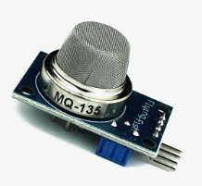
Figure 3.4 MQ135 Air Quality Sensor

      - Key Features
Broad-spectrum gas detection: Detects multiple harmful gases, including ammonia (NH₃), nitrogen oxides (NOx), benzene, smoke, and carbon dioxide (CO₂) simultaneously, eliminating the need for multiple separate sensors
Detection range of 10 ppm to 1000 ppm: Covers the full range of occupational exposure limits for most industrial air pollutants encountered in coal mines, chemical plants, and manufacturing facilities
High sensitivity with fast response time: Responds to gas presence within 10 seconds, enabling real-time air quality monitoring and immediate hazard detection before workers experience harmful exposure effects
Analog voltage output for easy interfacing: Provides an analog signal proportional to gas concentration for direct connection to ESP32 ADC pins without requiring additional signal conditioning circuits
      - Advantages
Comprehensive detection of multiple pollutants: Detects ammonia, nitrogen oxides, benzene, smoke, and carbon dioxide with a single sensor, eliminating the need for multiple separate gas sensors and reducing system complexity, cost, and power consumption
Real-time hazard detection with fast response: Responds to gas presence within 10 seconds, enabling immediate alert activation and automated safety responses before workers experience harmful exposure effects
Simple integration with ESP32: Analog output connects directly to ESP32 ADC pins without additional signal conditioning circuits, reducing hardware complexity and development time, and enabling easy implementation in IoT-based systems.
    - DHT11 Sensor
      - General Description
The DHT11 is a low-cost digital sensor used for measuring temperature and humidity in environmental monitoring applications. It contains a calibrated sensor module that provides reliable readings of temperature ranging from 0°C to 50°C and humidity levels from 20% to 90% with digital signal output. The sensor communicates directly with microcontrollers such as ESP32 and Arduino through a single-wire protocol, making interfacing simple and efficient.

Due to its low power consumption, compact size, and stable performance, the DHT11 is widely used in IoT systems, weather monitoring, smart home applications, and industrial safety systems for real-time environmental condition monitoring. The DHT11 sensor is designed with an internal capacitive humidity sensing element and a thermistor for temperature measurement, allowing it to provide accurate environmental data in real time. It features a built-in analog-to-digital conversion system that outputs calibrated digital values, eliminating the need for external signal processing circuits. The sensor is compact, easy to use, and suitable for continuous monitoring applications where environmental conditions must be tracked efficiently. The sensor provides stable and reliable performance with low maintenance requirements
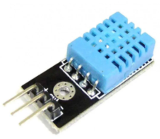
Figure 3.5 DHT11 Sensor
      - Key Features
Temperature measurement range: 0°C to 50°C (±2°C accuracy)
Humidity measurement range: 20% to 90% (±5% accuracy)
Sampling rate: 1 Hz (one reading per second)
Operating voltage: 3V to 5V DCLow power consumption for battery-based systems
Interface: Simple interface requiring only one GPIO pin
      - Advantages
Provides environmental context for gas sensor readings: Temperature and humidity data help compensate MQ135 and MQ7 readings, as gas sensor accuracy varies with environmental conditions
Simple one-wire interface: Connects to ESP32 using only one GPIO pin, saving valuable I/O pins for other sensors and output devices.

    - MAX30100 Pulse Oximeter Sensor
      - General Description
In Figure 3.6, MAX30100 is an integrated pulse oximetry and heart rate sensor module designed for wearable health monitoring applications. It combines two LEDs (red 660nm and infrared 940nm), a photodetector, and signal processing circuitry in a single compact module.
It works on the principle of photoplethysmography (PPG), where light absorption changes in blood flow are used to measure physiological parameters. When placed on the fingertip or earlobe, variations in blood volume allow the sensor to calculate heart rate and oxygen saturation (SpO₂). This helps in detecting abnormal conditions such as low oxygen levels or irregular heart rate. The compact design makes it suitable for wearable health monitoring systems. The sensor communicates with the ESP32 using the I²C protocol (SDA and SCL lines). In the proposed system, it continuously monitors worker health parameters to detect early signs of respiratory distress, such as hypoxemia and abnormal heart rate
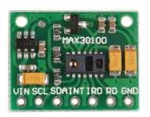
Figure 3.6 MAX30100 Pulse Oximeter Sensor
      - Key Features
Integrated dual-LED light sources: Contains red LED (660nm) for oxygenated hemoglobin detection and infrared LED (940nm) for deoxygenated hemoglobin reference measurement
Photoplethysmography (PPG) based measurement: Detects volumetric changes in arterial blood during cardiac cycles for non-invasive heart rate and SpO₂ monitoring
      - Advantages
Continuous non-invasive health monitoring: Enables real-time tracking of heart rate and SpO₂ without drawing blood or causing discomfort, allowing early detection of hypoxemia (SpO₂ < 90%) and abnormal heart rate
Early detection of respiratory distress: Detects physiological deterioration before clinical symptoms appear, enabling immediate emergency alerts and oxygen support activation for workers exposed to toxic gases.
    - HEPA Filter Sheet
      - Features
99.97% filtration efficiency at 0.3 microns: Captures 99.97% of particles of size 0.3 µm (most penetrating particle size - MPPS). Figure 3.7 shown
Multi-mechanism filtration: Uses diffusion, interception, and impaction to remove airborne particles effectively
High dust holding capacity: Maintains filtration performance for a longer duration before replacement is required

Figure 3.7 HEPA Filter Sheet
      - Advantages
High-efficiency air purification: Removes up to 99.97% of particles ≥ 0.3 microns, ensuring clean and safe breathable air for workers.
Reliable protection in harsh environments: Effectively filters dust, smoke, and industrial pollutants even in high-dust and humid working conditions.
    - Activated Carbon Filter
      - Features
High surface area of 500-1500 m²/g: Provides extensive adsorption sites for gas molecules through van der Waals forces Figure 3.8 Shown.
Gas and vapor adsorption: Removes volatile organic compounds (VOCs), chemical vapors, odors, and toxic gases
High adsorption capacity: Effectively captures ammonia, benzene, and industrial chemical pollutants
      - Advantages
High-efficiency air purification: Removes up to 99.97% of particles ≥ 0.3 microns, ensuring clean and safe breathable air for workers.
Reliable protection in harsh environments: Effectively filters dust, smoke, and industrial pollutants even in high-dust and humid working conditions
Effective gas and odor removal: Absorbs harmful gases, volatile organic compounds (VOCs), and unpleasant odors, improving overall air quality.
Chemical adsorption capability: Traps toxic chemicals and industrial fumes through adsorption, enhancing worker safety in hazardous environments.
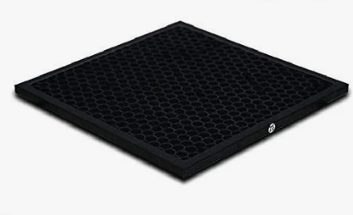
Figure 3.8 Activated Carbon Filter Sheet
    - LCD Display
      - Features
16 characters x 2 lines display format: Shows 32 characters total for clear presentation of gas concentrations, temperature, humidity, heart rate, and SpO₂ readings simultaneously
I²C interface with backlight: Uses only SDA and SCL pins for ESP32 connection, saving GPIO pins; built-in backlight enables reading in low-light industrial environments
Wide operating temperature of -20°C to +70°C: Suitable for harsh industrial environments, including coal mines, chemical plants, and outdoor construction sites. Figure 3.8 Shown.
      - Advantages
Local real-time display without mobile devices: Shows live sensor readings directly on the device, allowing workers to monitor their environmental exposure and health status without smartphones or cloud access
I²C interface saves ESP32 GPIO pins: Uses only 2 pins (SDA, SCL) instead of 6 pins required for standard parallel LCD interface, leaving more pins available for sensors and output devices
Immediate visual alert indication: Displays warning messages the moment gas concentrations exceed safety thresholds or health parameters indicate distress, enabling quick worker response
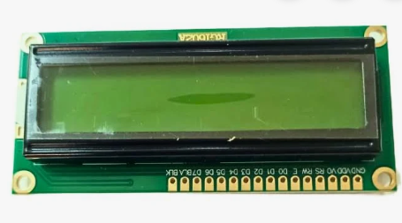
Figure 3.9 LCD Display
    - Buzzer
      - Features
Operating voltage of 3V to 5V: Compatible with ESP32's 3.3V logic level and system's 5V power supply, requiring no additional voltage conversion
Sound output of 80-100 dB: Loud enough to be heard clearly in noisy industrial environments with high ambient noise levels from machinery and equipment
Operating frequency of 2-4 kHz: Optimal frequency range for human ear detection, effectively penetrating through background industrial noise. Figure 3.10 shown
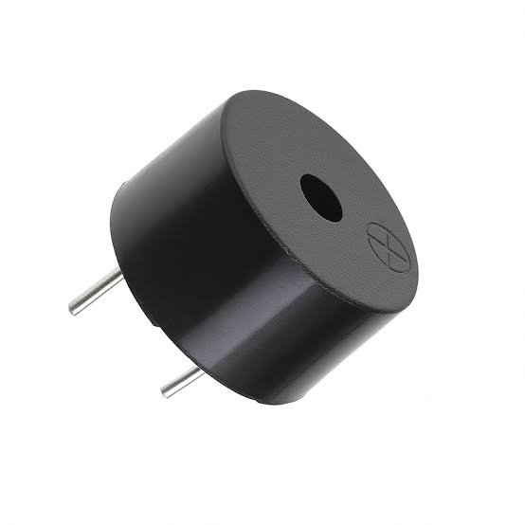
Figure 3.10 Buzzer
      - Advantages
Immediate audible hazard warning: Alerts worker instantly when gas concentrations exceed safety thresholds or when SpO₂ drops below 90%, enabling rapid evacuation or emergency response
Simple two-pin interface with ESP32: Connects directly to ESP32 GPIO pin and ground without requiring additional driver circuits or signal conditioning components
Effective in high-noise industrial environments: 85-95 dB sound output ensures alerts are heard over machinery noise common in coal mines, chemical plants, and manufacturing facilities
    - BC547 Transistor
3.5.10.1 Features
NPN bipolar junction transistor with 100 mA collector current rating: Capable of switching oxygen flow valves and small actuators requiring up to 100 mA current
Low base trigger voltage of 0.7V: Can be directly controlled by ESP32's 3.3V GPIO output without additional driver circuits
Small TO-92 package: Compact through-hole design for easy integration into wearable smart mask PCB, Figure 3.11 shown
3.5.10.2 Advantages
Enables ESP32 to control high-power devices: Allows low-power 3.3V ESP32 GPIO pins to switch oxygen flow valves requiring higher current, protecting the microcontroller from damage
Automatic emergency oxygen activation: Triggers oxygen flow instantly when SpO₂ falls below 90%, or CO exceeds 100 ppm, providing life-saving respiratory support without worker intervention
Low-cost switching solution: Provides reliable electronic switching at significantly lower cost than mechanical relays, with no moving parts to wear out
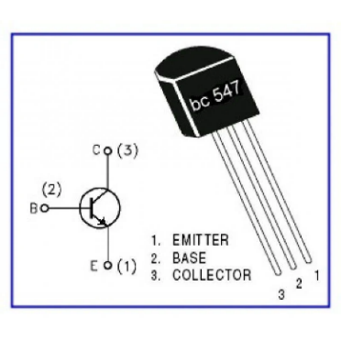
Figure 3.11 BC547 Transistor

  - SOFTWARE DESCRIPTION
3.6.1 Arduino IDE
Arduino IDE (Integrated Development Environment) is an open-source software platform used for writing, compiling, and uploading code to Arduino-compatible microcontroller boards, including the ESP32. It provides a user-friendly interface with a code editor, compiler, serial monitor, and library manager, making it accessible for beginners while powerful enough for advanced embedded system development.
The IDE supports C and C++ programming languages with simplified syntax and built-in functions for hardware control. The ESP32 can be programmed using the Arduino IDE by installing the ESP32 board package through the Boards Manager, which adds ESP32-specific libraries, toolchains, and example sketches. The built-in serial monitor enables real-time debugging and data visualization by displaying serial output from the ESP32 during program execution.
    - Blynk IoT Platform
Blynk is an IoT (Internet of Things) platform specifically designed for building mobile applications and dashboards to monitor and control microcontroller-based systems remotely. It provides a drag-and-drop interface builder, cloud server infrastructure, and mobile apps for Android and iOS devices. The platform handles device authentication, data storage, push notifications, and real-time data visualization without requiring complex backend programming. The ESP32 connects to the Blynk cloud server using the Blynk library over Wi-Fi. The library handles Wi-Fi connection, data transmission, authentication, and reconnection automatically. Data from sensors is sent to Blynk virtual pins, where it can be displayed on widgets such as gauges, graphs, value displays, and notification widgets.
In the proposed system, the Blynk platform is used to create a real-time monitoring dashboard for safety supervisors. The dashboard displays live sensor readings, including gas concentrations, temperature, humidity, heart rate, and SpO₂ from each worker's smart mask. When hazardous conditions are detected, the platform sends instant push notifications to the supervisor's mobile devices for immediate emergency response.
    - Wi-Fi Communication Using ESP32
Wi-Fi communication enables wireless data transmission between the ESP32 microcontroller and the Blynk IoT cloud platform. The ESP32 integrates a 2.4 GHz 802.11 b/g/n Wi-Fi module that supports both station mode (connecting to existing Wi-Fi networks) and access point mode (creating its own network).
In the proposed system, the ESP32 operates in station mode, connecting to the facility's existing Wi-Fi infrastructure to transmit sensor data to the cloud. The Wi-Fi communication follows a client-server architecture where the ESP32 acts as a client, establishing a TCP connection to the Blynk cloud server. Data is transmitted using the MQTT (Message Queuing Telemetry Transport) protocol.
The Blynk IoT platform allows supervisors to monitor worker conditions in real time through a mobile application or web dashboard. Whenever sensor values exceed predefined safety limits, the system instantly sends alert notifications through the internet, enabling quick emergency response. Wi-Fi communication also supports continuous cloud data logging, remote monitoring of multiple workers, and efficient management of industrial safety systems without the need for wired connections. The wireless communication system improves portability and flexibility of the smart mask by eliminating complex wired setups. It also enables long-distance monitoring within industrial environments.
The Blynk IoT platform enables supervisors and safety personnel to monitor worker health and environmental conditions in real time through a mobile application or web dashboard. Whenever sensor readings exceed predefined safety thresholds, the ESP32 immediately sends emergency notifications and warning alerts through the internet. This rapid communication mechanism helps in taking quick corrective actions during hazardous situations and improves worker safety in industrial environments.
Wi-Fi communication also supports continuous cloud data logging, allowing historical sensor data to be stored and analyzed for safety assessment and performance evaluation. Multiple workers can be monitored simultaneously from a centralized control interface without requiring complex wired communication systems. The wireless communication feature improves portability, flexibility, and ease of deployment of the smart safety mask system. Additionally, remote firmware updates, cloud synchronization, and real-time monitoring make the ESP32-based IoT system highly efficient and reliable for modern industrial safety applications.
Furthermore, the Wi-Fi-enabled ESP32 system enhances emergency response capabilities by instantly transmitting alert notifications whenever hazardous gas concentrations or abnormal health conditions are detected. The real-time communication between sensors, cloud platforms, and monitoring devices enables supervisors to take immediate preventive actions to ensure worker safety.

CHAPTER 4
RESULTS AND DISCUSSION

4.1 RESULTS
The proposed IoT-based smart air-purifying system was successfully implemented and tested under various environmental conditions to evaluate its performance in monitoring hazardous gases, tracking worker health parameters, generating alerts, and transmitting data to the IoT platform. The experimental results are presented in the following sections.
4.1.1 Hardware Performance
The hardware module of the proposed system was assembled using the ESP32 microcontroller, MQ135 air quality sensor, MQ7 carbon monoxide sensor, DHT11 temperature and humidity sensor, MAX30100 pulse oximeter sensor, LCD display, buzzer, CPU fan, HEPA filter, activated carbon filter, and BC547 transistor with a rechargeable Li-ion battery and voltage regulator circuit Figure 4.1 Shown
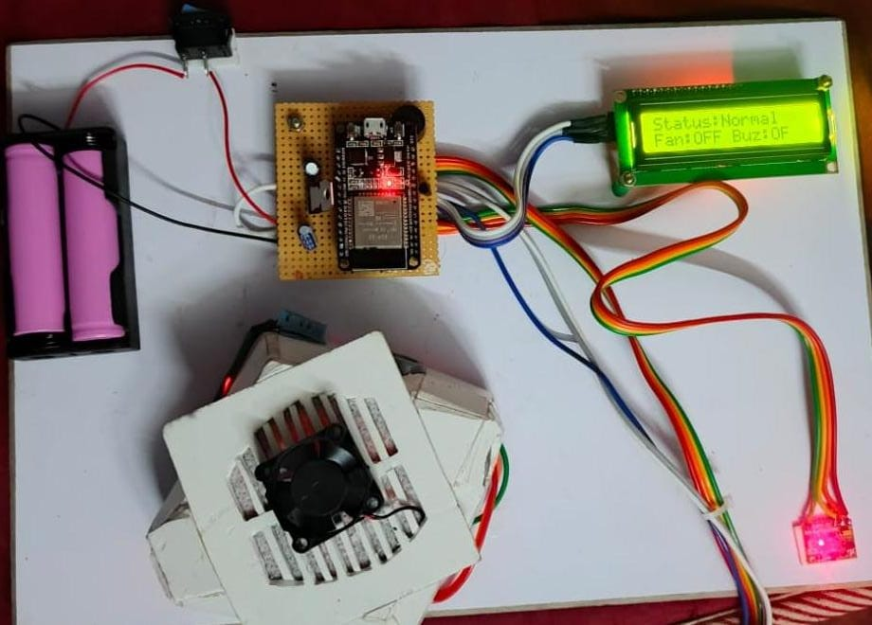

Figure 4.1 Hardware Module of the Proposed System

Air Quality Monitoring
The air quality monitoring system performed effectively in detecting harmful gases. The MQ135 sensor was able to detect gases such as ammonia (NH₃), nitrogen oxides (NOx), benzene, smoke, and carbon dioxide (CO₂). The MQ7 sensor accurately measured carbon monoxide concentrations within the range of 20 ppm to 2000 ppm, while normal levels (0–10 ppm) were correctly identified as safe. The system responded quickly to variations in gas concentration and provided real-time updates, successfully identifying hazardous environmental conditions. Figure 4.2 shown
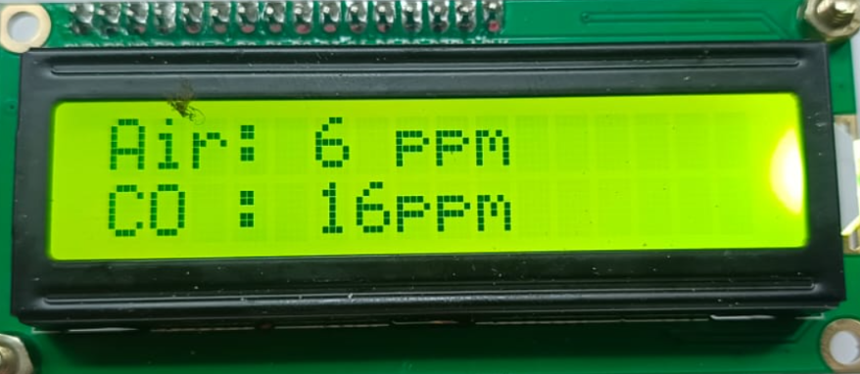
Figure 4.2 Air Quality Monitoring

Temperature and Humidity Monitoring
The DHT11 sensor provided stable and consistent measurements of temperature and humidity. It accurately measured temperature within the range of 0°C to 50°C and humidity between 20% and 90%. These environmental parameters played an important role in interpreting gas sensor readings, as gas sensors are sensitive to temperature and humidity variations. The measured values were displayed in real time on the LCD, allowing easy monitoring of environmental conditions. Additionally, the DHT11 sensor demonstrated reliable performance under varying environmental conditions, ensuring continuous data acquisition without significant fluctuations. The integration of temperature and humidity data helped improve the accuracy of overall system analysis and decision-making. This contributed to enhancing the effectiveness of the air quality monitoring and safety system for industrial workers. This also ensured better calibration and reliability of the gas sensing module over time the sensor’s low power consumption made it suitable for continuous operation in portable and wearable systems. The compact design of the DHT11 allowed easy integration with the overall hardware setup without increasing system complexity. This improved the efficiency and practicality of the monitoring system for real-world industrial applications Figure 4.3 Shown.

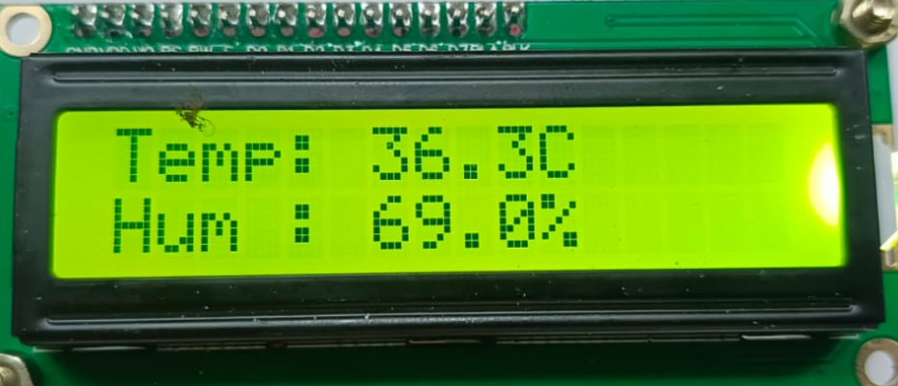
Figure 4.3 Temperature and Humidity Monitoring

Pulse Rate and SpO₂ Monitoring
The MAX30100 sensor effectively monitored the worker’s heart rate and blood oxygen saturation (SpO₂). The system correctly identified normal heart rate values in the range of 60–100 BPM and SpO₂ levels above 95%. It also detected abnormal conditions such as low SpO₂ (below 90%) and irregular heart rate. Continuous monitoring enabled early detection of potential health issues, improving worker safety in hazardous environments Figure 4.4 shown.

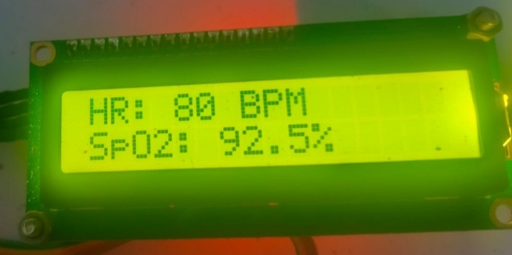
Figure 4.4 Heart Rate Monitoring

Alert System Performance
The alert system performed efficiently by providing immediate warnings under unsafe conditions. The buzzer was activated whenever gas concentrations exceeded safety thresholds or when physiological parameters indicated distress. The LCD showed clear warning messages to inform the user. The response time of the system was fast, ensuring that alerts were generated without delay, which is critical for preventing accidents and health risks the alert system ensured real-time responsiveness even under continuous monitoring conditions. The combination of audible and visual alerts improved user awareness and quick reaction to hazardous situations. This enhanced the overall reliability and safety performance of the system in industrial environments Figure 4.5 Shown.
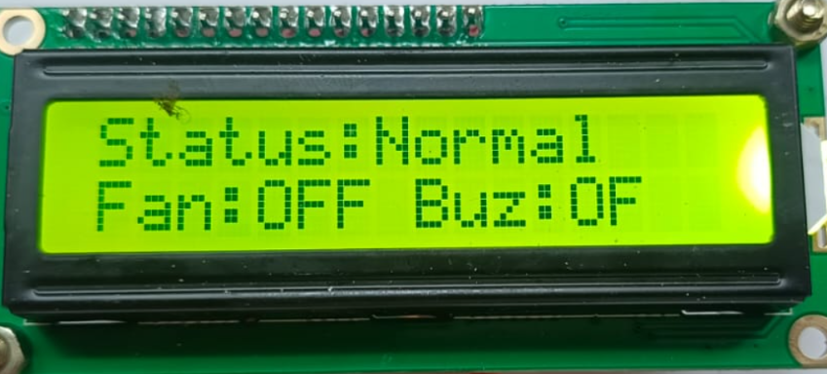

Figure 4.5 Alert System Monitoring
Table 4.1 Sensor Threshold Analysis
Parameter | Threshold Value | Response
Air Quality | 500 ppm | Fan and Buzzer ON
Carbon Monoxide | 40 ppm | Alert Generated
Temperature | 37°C | Warning Activated
Heart Rate | 40 – 200 BPM | Health Monitoring
SpO₂ Level | Below 90% | Oxygen Alert
Finger Detection | IR > 30000 | Sensor Activated

The threshold values used in the proposed system help in detecting abnormal environmental and health conditions in real time. The MQ135 and MQ7 sensors monitor air quality and carbon monoxide concentration to identify hazardous gas exposure. The DHT11 sensor measures temperature variations, while the MAX30100 sensor tracks heart rate and SpO₂ levels for worker health monitoring. Whenever the sensor readings exceed the predefined safety limits, the system activates alerts such as the buzzer and exhaust fan. The ESP32 controller continuously processes sensor data and performs threshold comparison for efficient monitoring. Real-time alerts enable quick response during emergency situations and reduce the risk of worker exposure to harmful conditions. This improves overall system reliability and enhances industrial worker safety. The threshold values and corresponding system responses are presented in Table 4.1.

4.1.2 IoT Monitoring Interface

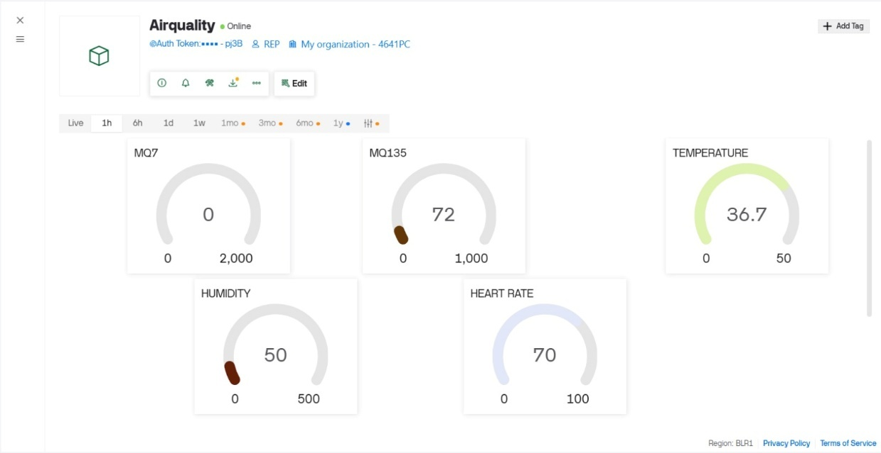
Figure 4.6 Software Interface of Proposed System
The IoT monitoring system functioned successfully using the Blynk platform. The ESP32 transmitted real-time sensor data via Wi-Fi, and the data was displayed on the mobile application dashboard. The system generated instant notifications when abnormal conditions were detected, enabling quick response from supervisors. Additionally, the data was stored in the cloud, allowing remote monitoring and analysis of worker safety conditions from any location Figure 4.6 shown.
4.2 DISCUSSION
4.2.1 System Analysis
The overall system performance demonstrates that the proposed IoT-based smart air-purifying system is capable of integrating environmental monitoring, health tracking, and air purification into a single wearable solution. The ESP32 microcontroller efficiently handled multiple sensor inputs and executed real-time processing without significant delay. The combination of sensing, processing, alert generation, and communication modules worked in a coordinated manner, forming a reliable closed-loop system. The integration of filtration, monitoring, and alert mechanisms provides a comprehensive approach to worker safety, overcoming the limitations of traditional standalone monitoring systems.
4.2.2 Sensor Response
The sensors used in the system showed satisfactory response under varying environmental conditions. The MQ135 and MQ7 sensors effectively detected changes in gas concentrations, although slight variations were observed due to sensitivity to temperature and humidity. The DHT11 sensor provided stable environmental readings that helped in interpreting gas sensor outputs. The MAX30100 sensor delivered consistent heart rate and SpO₂ measurements, enabling reliable health monitoring. Overall, the sensors exhibited acceptable accuracy and response time for real-time applications, making them suitable for industrial safety systems.
4.2.3 Worker Safety Improvement
The proposed system significantly enhances worker safety by providing continuous monitoring of both environmental and physiological parameters. Unlike conventional safety systems that rely only on periodic checks or stationary monitoring devices, this system offers real-time, personalized protection. Early detection of hazardous gases and abnormal health conditions allows timely alerts and preventive actions. The inclusion of air purification and emergency oxygen support further strengthens protection by not only detecting risks but also actively reducing exposure.
Table 4.2 Overall System Performance Analysis
System Feature | Performance | Result
Gas Detection | Real-time monitoring | Successful
Health Monitoring | Continuous monitoring | Reliable
Alert System | Automatic warning generation | Fast response
IoT Communication | Live data transmission | Stable connectivity
Overall System | Integrated safety monitoring | Efficient performance

The overall performance analysis shows that the proposed system efficiently monitors environmental and physiological conditions in real time. The IoT-based communication enables continuous live data transmission and remote supervision through the Blynk platform. The performance evaluation presented in Table 4.2 confirms the reliability and effectiveness of the proposed smart worker safety system
CHAPTER 5
CONCLUSION AND FUTURE SCOPE

  - CONCLUSION
This project successfully developed an IoT-based smart air-purifying system for monitoring hazardous environments and worker health. It integrates MQ135, MQ7, DHT11, and MAX30100 sensors with an ESP32 for real-time data processing and IoT communication. The system overcomes the limitations of traditional safety methods by combining environmental and health monitoring in a single device. It provides continuous real-time data, improving early detection of dangerous conditions. The design is compact and suitable for wearable applications in industrial environments. It ensures better protection compared to conventional monitoring systems.
The system provides effective air purification using HEPA and activated carbon filters, along with automatic fan control. It generates alerts through a buzzer and LCD, and activates emergency oxygen support during critical conditions. The IoT-based monitoring allows remote supervision of workers. It also helps in faster emergency response and improved safety management.
The Blynk IoT platform enables real-time remote monitoring and notifications. Overall, the system is portable, cost-effective, and enhances worker safety in industrial environments. The platform allows seamless data visualization through mobile applications, making it user-friendly and accessible. Instant alerts and updates improve response time during critical situations. This connectivity ensures better coordination between workers and supervisors for enhanced safety management.
  - FUTURE SCOPE
The proposed system can be further enhanced by integrating additional gas sensors such as hydrogen sulfide (H₂S), methane (CH₄), and volatile organic compounds (VOCs) to support a wider range of industrial environments. Future improvements may include the addition of a GPS module for real-time worker location tracking, enabling faster emergency response and better safety management. The implementation of machine learning algorithms can also help in predicting hazardous conditions based on historical data, allowing preventive measures instead of only reactive alerts. Voice feedback systems can be added to assist workers in low-visibility conditions where LCDs may not be clearly visible.

APPENDIX
PROGRAM CODE :
#define BLYNK_AUTH_TOKEN "yt-aHtgfn358hXI3wpa5fOfPx2mepj3B"
#define BLYNK_TEMPLATE_ID "TMPL3WqdwAfRK"
#define BLYNK_TEMPLATE_NAME "Airquality"
#define BLYNK_PRINT Serial
#include <Wire.h>
#include <LiquidCrystal_I2C.h>
#include <DHT.h>
#include <WiFi.h>
#include <BlynkSimpleEsp32.h>
char ssid[] = "project";
char pass[] = "12345678";
LiquidCrystal_I2C lcd(0x27, 16, 2);
#define MQ135_PIN 34
#define MQ7_PIN 35
#define DHT_PIN 4
#define DHT_TYPE DHT11
#define BUZZER_PIN 25 // Active buzzer → GPIO25 → GND
#define FAN_PIN 26 // BC547 Base via 1kΩ → GPIO26
#define MQ135_THRESHOLD_PPM 500.0f // Poor air quality above 400 ppm
#define MQ7_THRESHOLD_PPM 40.0f // Dangerous CO above 10 ppm
#define TEMP_THRESHOLD 37.0f // Fever above 37°C
#define SDA_PIN 21
#define SCL_PIN 22
#define MAX30100_I2C_ADDRESS 0x57
#define REG_FIFO_WR_PTR 0x02
#define REG_OVRFLOW_CTR 0x03
#define REG_FIFO_RD_PTR 0x04
#define REG_FIFO_DATA 0x05
#define REG_MODE_CONFIG 0x06
#define REG_SPO2_CONFIG 0x07
#define REG_LED_CONFIG 0x09
#define REG_PART_ID 0xFF
#define FINGER_THRESHOLD 30000
DHT dht(DHT_PIN, DHT_TYPE);
float mq135ToPPM(int raw) {
float ppm = ((float)raw / 4095.0f) * 1000.0f;
return constrain(ppm, 0.0f, 1000.0f);
}
float mq7ToPPM(int raw) {
float ppm = ((float)raw / 4095.0f) * 100.0f;
return constrain(ppm, 0.0f, 100.0f);
}
float mq135ToPercent(float ppm) {
return constrain((ppm / 1000.0f) * 100.0f, 0.0f, 100.0f);
}
float mq7ToPercent(float ppm) {
return constrain((ppm / 100.0f) * 100.0f, 0.0f, 100.0f);
}
void writeRegister(uint8_t reg, uint8_t value) {
Wire.beginTransmission(MAX30100_I2C_ADDRESS);
Wire.write(reg);
Wire.write(value);
Wire.endTransmission();
}
uint8_t readRegister(uint8_t reg) {
Wire.beginTransmission(MAX30100_I2C_ADDRESS);
Wire.write(reg);
Wire.endTransmission(false);
Wire.requestFrom(MAX30100_I2C_ADDRESS, 1);
return Wire.read();
}
void readFIFO(uint16_t &ir, uint16_t &red) {
Wire.beginTransmission(MAX30100_I2C_ADDRESS);
Wire.write(REG_FIFO_DATA);
Wire.endTransmission(false);
Wire.requestFrom(MAX30100_I2C_ADDRESS, 4);
uint8_t b0 = Wire.read(), b1 = Wire.read();
uint8_t b2 = Wire.read(), b3 = Wire.read();
red = ((uint16_t)b0 << 8) | b1;
ir = ((uint16_t)b2 << 8) | b3;
}
void initMAX30100() {
writeRegister(REG_MODE_CONFIG, 0x40);
delay(100);
writeRegister(REG_MODE_CONFIG, 0x03);
writeRegister(REG_SPO2_CONFIG, 0x47);
writeRegister(REG_LED_CONFIG, 0xFF);
writeRegister(REG_FIFO_WR_PTR, 0x00);
writeRegister(REG_OVRFLOW_CTR, 0x00);
writeRegister(REG_FIFO_RD_PTR, 0x00);
}
struct DCFilter {
float w = 0;
float step(float x) {
float pw = w;
w = x + 0.95f * w;
return w - pw;
}};
struct MeanFilter {
float buf[10] = {0};
int idx = 0;
float step(float x) {
buf[idx] = x;
idx = (idx + 1) % 10;
float s = 0;
for (int i = 0; i < 10; i++) s += buf[i];
return s / 10.0f;
}};
struct BeatDetector {
float threshold = 20.0f, prev = 0;
bool rising = false;
long lastBeat = 0;
float bpmBuffer[8] = {0};
int bpmIdx = 0, bpmCount = 0;
float avgBPM = 0;
void step(float value, long now) {
if (value > prev) rising = true;
if (rising && value < prev && prev > threshold) {
rising = false;
threshold = prev * 0.6f;
if (lastBeat > 0) {
float bpm = 60000.0f / (float)(now - lastBeat);
if (bpm >= 40 && bpm <= 200) {
bpmBuffer[bpmIdx % 8] = bpm;
bpmIdx++;
if (bpmCount < 8) bpmCount++;
float sum = 0;
for (int i = 0; i < bpmCount; i++) sum += bpmBuffer[i];
avgBPM = sum / bpmCount;
}}
lastBeat = now;
}
threshold *= 0.99f;
if (threshold < 5.0f) threshold = 5.0f;
prev = value;
}
void reset() {
avgBPM = 0; bpmCount = 0; bpmIdx = 0;
lastBeat = 0; threshold = 20.0f;
for (int i = 0; i < 8; i++) bpmBuffer[i] = 0;
}};
struct SpO2Calculator {
float irDC = 0, redDC = 0, spo2 = 0;
float spo2Buffer[8] = {0};
int idx = 0, count = 0;
void step(float ir, float red) {
irDC = irDC * 0.95f + ir * 0.05f;
redDC = redDC * 0.95f + red * 0.05f;
if (irDC < 1000 || redDC < 1000) return;
float irAC = ir - irDC, redAC = red - redDC;
float R = (redAC / redDC) / (irAC / irDC);
float sp = 110.0f - 25.0f * R;
if (sp > 100) sp = 100;
if (sp < 80) return;
spo2Buffer[idx % 8] = sp;
idx++;
if (count < 8) count++;
float sum = 0;
for (int i = 0; i < count; i++) sum += spo2Buffer[i];
spo2 = sum / count;
}
void reset() {
spo2 = 0; idx = count = 0; irDC = redDC = 0;
}};
DCFilter irDCFilter;
MeanFilter irMeanFilter;
BeatDetector beatDetector;
SpO2Calculator spo2Calc;
bool fingerOn = false;
int noFingerCount = 0;
uint32_t lastPrint = 0;
uint8_t lcdPage = 0;
uint32_t lastLCDSwitch = 0;
uint32_t lastBlynkSend = 0;
float g_mq135ppm = 0, g_mq7ppm = 0;
float g_mq135pct = 0, g_mq7pct = 0;
float g_temp = 0, g_hum = 0;
bool g_alert = false, g_fanOn = false;
void setup() {
Serial.begin(115200);
delay(1000);
pinMode(BUZZER_PIN, OUTPUT);
digitalWrite(BUZZER_PIN, LOW);
pinMode(FAN_PIN, OUTPUT);
digitalWrite(FAN_PIN, LOW); // Fan OFF initially
Wire.begin(SDA_PIN, SCL_PIN);
Wire.setClock(400000);
lcd.init();
lcd.backlight();
lcd.setCursor(0, 0); lcd.print("Air Quality Mon.");
lcd.setCursor(0, 1); lcd.print("Connecting WiFi.");
delay(500);
dht.begin();
WiFi.begin(ssid, pass);
Serial.print("Connecting WiFi");
int tries = 0;
while (WiFi.status() != WL_CONNECTED && tries < 20) {
delay(500); Serial.print("."); tries++;
}
if (WiFi.status() == WL_CONNECTED) {
Serial.println("\nWiFi Connected! IP: " + WiFi.localIP().toString());
Blynk.config(BLYNK_AUTH_TOKEN);
Blynk.connect();
lcd.clear();
lcd.setCursor(0, 0); lcd.print("WiFi Connected!");
lcd.setCursor(0, 1); lcd.print(WiFi.localIP().toString());
delay(1500);
} else {
Serial.println("\nWiFi Failed - Offline mode.");
lcd.clear();
lcd.setCursor(0, 0); lcd.print("WiFi Failed!");
lcd.setCursor(0, 1); lcd.print("Offline Mode");
delay(1500);
}
if (readRegister(REG_PART_ID) != 0x11) {
Serial.println("MAX30100 not found!");
lcd.clear(); lcd.setCursor(0, 0); lcd.print("MAX30100 Error!");
while (1);
}
initMAX30100();
lcd.clear();
lcd.setCursor(0, 0); lcd.print("System Ready!");
lcd.setCursor(0, 1); lcd.print("Place finger...");
delay(1000);
lcd.clear();
Serial.println("System Ready.");
}
void loop() {
if (Blynk.connected()) Blynk.run();
uint16_t irRaw, redRaw;
readFIFO(irRaw, redRaw);
if (irRaw <= FINGER_THRESHOLD) {
if (++noFingerCount > 50 && fingerOn) {
fingerOn = false;
beatDetector.reset();
spo2Calc.reset();
Serial.println("No finger detected.");
}
} else {
noFingerCount = 0;
fingerOn = true;
float irFiltered = irDCFilter.step((float)irRaw);
float irSmooth = irMeanFilter.step(irFiltered);
beatDetector.step(irSmooth, millis());
spo2Calc.step((float)irRaw, (float)redRaw);
}
if (millis() - lastPrint >= 1000) {
lastPrint = millis();
int mq135Raw = analogRead(MQ135_PIN);
int mq7Raw = analogRead(MQ7_PIN);
g_mq135ppm = mq135ToPPM(mq135Raw);
g_mq7ppm = mq7ToPPM(mq7Raw);
g_mq135pct = mq135ToPercent(g_mq135ppm);
g_mq7pct = mq7ToPercent(g_mq7ppm);
g_temp = dht.readTemperature();
g_hum = dht.readHumidity();
bool mq135Alert = (g_mq135ppm > MQ135_THRESHOLD_PPM);
bool mq7Alert = (g_mq7ppm > MQ7_THRESHOLD_PPM);
bool tempAlert = (!isnan(g_temp) && g_temp > TEMP_THRESHOLD);
g_alert = mq135Alert || mq7Alert || tempAlert;
if (g_alert) {
digitalWrite(BUZZER_PIN, HIGH); delay(150);
digitalWrite(BUZZER_PIN, LOW); delay(100);
digitalWrite(BUZZER_PIN, HIGH); delay(150);
digitalWrite(BUZZER_PIN, LOW);
} else {
digitalWrite(BUZZER_PIN, LOW) }
bool gasAlert = mq135Alert || mq7Alert;
if (gasAlert) {
digitalWrite(FAN_PIN, HIGH); // Fan ON when gas detected
g_fanOn = true;
} else {
digitalWrite(FAN_PIN, LOW); // Fan OFF when normal
g_fanOn = false; }
Serial.println("========== SENSOR DATA ==========");
if (!fingerOn) {
Serial.println("Heart Rate: Place finger...");
Serial.println("SpO2 : Place finger...");
} else {
Serial.print("Heart Rate: ");
beatDetector.avgBPM > 0 ? Serial.print(beatDetector.avgBPM, 1), Serial.println(" BPM")
: Serial.println("Calculating...");
Serial.print("SpO2 : ");
spo2Calc.spo2 > 0 ? Serial.print(spo2Calc.spo2, 1), Serial.println(" %")
: Serial.println("Calculating...");
}
Serial.print("MQ135 Air : "); Serial.print(g_mq135ppm, 1);
Serial.print(" ppm ("); Serial.print(g_mq135pct, 1); Serial.println("%)");
Serial.print("MQ7 CO : "); Serial.print(g_mq7ppm, 1);
Serial.print(" ppm ("); Serial.print(g_mq7pct, 1); Serial.println("%)");
if (!isnan(g_temp)) {
Serial.print("Temp : "); Serial.print(g_temp, 1); Serial.println(" C");
Serial.print("Humidity : "); Serial.print(g_hum, 1); Serial.println(" %");
} else {
Serial.println("DHT11 : Read Error");
}
Serial.print("ALERT : "); Serial.println(g_alert ? "YES ⚠" : "No");
Serial.print("FAN : "); Serial.println(g_fanOn ? "ON" : "OFF");
Serial.println("=================================");
if (millis() - lastLCDSwitch >= 2000) {
lastLCDSwitch = millis();
lcd.clear();
switch (lcdPage) {
case 0: // HR & SpO2
lcd.setCursor(0, 0);
if (!fingerOn) {
lcd.print("Place finger...");
} else {
lcd.print("HR: ");
if (beatDetector.avgBPM > 0) {
lcd.print((int)beatDetector.avgBPM);
lcd.print(" BPM");
} else {
lcd.print("Calc...");
} }
lcd.setCursor(0, 1);
lcd.print("SpO2: ");
if (spo2Calc.spo2 > 0) {
lcd.print(spo2Calc.spo2, 1); lcd.print("%");
} else {
lcd.print("Calc...");
}
break;
case 1: // Temp & Humidity
lcd.setCursor(0, 0);
lcd.print("Temp: ");
if (!isnan(g_temp)) {
lcd.print(g_temp, 1); lcd.print("C");
if (g_temp > TEMP_THRESHOLD) lcd.print(" !");
} else { lcd.print("Error"); }
lcd.setCursor(0, 1);
lcd.print("Hum : ");
if (!isnan(g_hum)) {
lcd.print(g_hum, 1); lcd.print("%");
} else { lcd.print("Error"); }
break;
case 2: // MQ135, MQ7 Air Quality
lcd.setCursor(0, 0);
lcd.print("Air: ");
lcd.print(g_mq135ppm, 0); lcd.print(" ppm");
if (g_mq135ppm > MQ135_THRESHOLD_PPM) lcd.print("!");
lcd.setCursor(0, 1);
lcd.print("CO : ");
lcd.print(g_mq7ppm, 0); lcd.print("ppm");
break;
case 3: // Alert & Fan status
lcd.setCursor(0, 0);
lcd.print(g_alert ? "!! ALERT !!" : "Status:Normal ");
lcd.setCursor(0, 1);
lcd.print("Fan:");
lcd.print(g_fanOn ? "ON " : "OFF ");
lcd.print("Buz:");
lcd.print(g_alert ? "ON" : "OF");
break;
}
lcdPage = (lcdPage + 1) % 4;
}
if (Blynk.connected() && millis() - lastBlynkSend >= 2000) {
lastBlynkSend = millis();
Blynk.virtualWrite(V0, beatDetector.avgBPM > 0 ? beatDetector.avgBPM : 0);
Blynk.virtualWrite(V1, spo2Calc.spo2 > 0 ? spo2Calc.spo2 : 0);
Blynk.virtualWrite(V2, !isnan(g_temp) ? g_temp : 0);
Blynk.virtualWrite(V3, !isnan(g_hum) ? g_hum : 0);
Blynk.virtualWrite(V4, g_mq135ppm);
Blynk.virtualWrite(V5, g_mq7ppm);
Blynk.virtualWrite(V6, g_alert ? 1 : 0);
Blynk.virtualWrite(V7, g_fanOn ? 1 : 0);
}
}
delay(10);
}

REFERENCES
1. | Abro, G. E. M., Shaikh, S. A., Soomro, S., Abid, G., Kumar, K., & Ahmed, F. (2018), ‘Prototyping IoT based Smart Wearable Jacket Design for Securing The Life Of Coal Miners’, International Conference on Computing, Electronics & Communications Engineering (iCCECE), pp.134-137.
2. | Anitha, M., & Kumar, L. S. (2023), ‘Development Of An Iot-Enabled Air Pollution Monitoring And Air Purifier System’, MAPAN, Vol no.38, Issue no.3, pp.669-688.
3. | Bandara, S., Minsilu, D., Karunarathne, M., & Edirisinghe, S. (2024), ‘Air Quality Monitoring In Industry 5.0 Using Edge Computing’, International Conference on Advanced Research in Computing (ICARC), pp.357-362.
4. | Devi, R., Ragavan, R., Sharmin Smiley, S., Aakash, T., & Kumar, C. (2025), ‘Air Quality Monitoring And Air Filtering System Using Iot’, International Conference on Research Methodologies in Knowledge Management, Artificial Intelligence and Telecommunication Engineering (RMKMATE), pp.1-6.
5. | Gopalka, P., Parikh, P., & Shah, P. (2025), ‘Design And Development Of An Iot-Enabled Smart Air-Purifying And Monitoring Mask For Hazardous Industrial Environments’, International Journal of Advanced Research, Vol no.13, Issue no.8, pp.187-198.
6. | Herath, H. M. R. G., Jayasundara, K. K. W. S. P. K., Yadhasighe, Y. K. A., & Sanjeewa, S. D. A. (2022), ‘The Design And Implementation Of An Iot-Based Real-Time Air Purification System For Outdoor Environment’, International Conference on Advanced Research in Computing (ICARC), pp.314-319.
7. | International Labour Organisation, Coal Mines Committee. (1976), ‘Safety And Health In Coal Mines’, International Labour Office, Vol no.10.
8. | Kadarkarai, P., Srinivasu, P. D. S., Ture, G. C., Reddy, R. J., & Reddy, T. R. R. (2025), ‘Iot Based Air Quality Monitoring And Air Purifier System’, International Conference on Trends in Material Science and Inventive Materials (ICTMIM), pp.1188-1192.
9. | Kanimozhi, J. K., Logesh, T., Prakash, N., & Kandasamy, C. A. (2025), ‘Iot-Enabled Air Purifiers With Real-Time Quality Monitoring’, International Conference on Soft Computing for Security Applications (ICSCSA), pp.652-656.
10. | Kavitha, D., Sasidharan, S., Gokul, S., Karthik, R., Latha, K., & Hemavathi, S. (2024), ‘Industry-Specific Iot-Based Air Pollution Monitoring System’, International Conference on Power, Energy, Control and Transmission Systems (ICPECTS), pp.1-4.
11. | Muttaki, M. R. A., Afrin, S., Anil, A. I. A., & Noon, H. F. (2026), ‘Iot-Based Monitoring And Automated Air Purification System For Industrial Pollution Control’, Doctoral dissertation, BRAC University.
12. | Ramadhani, I. G. A. I. F., Putri, T. Z., Asmarita, Y. D., Amania, S., Mufti, N., Mizar, M. A., & Arrosyid, H. (2025). ‘Iot Implementation For Air Quality Monitoring System Using Low Cost Sensor’, International Conference on Industry 4.0, Artificial Intelligence, and Communications Technology (IAICT), pp.621-627.
13. | Vakharia, A., & Chavan, A. (2025), ‘Development Of A Compact Iot-Enabled Air Purification System For Indoor Air Quality Improvement’, International Conference on Trends in Material Science and Inventive Materials (ICTMIM), pp.1115-1123.
14. | Veena, S., Vanathi, A., SadikBasha, S., Salma, U., Naveena, M., & Pavithra, N. (2025), ‘Real-Time Design Of Coal Mine Safety Monitoring With Alerting Intelligence Using Iot With Logical Sensors’, International Conference on Science Technology Engineering and Mathematics (ICONSTEM), pp.1-9.
15. | Veeramanikandasamy, T., Raj, S. G., Balamurugan, A., Ramesh, A. P., & Khadar, Y. S. (2020), ‘Iot Based Real-Time Air Quality Monitoring And Control System To Improve The Health And Safety Of Industrial Workers’, International Journal of Innovative Technology and Exploring Engineering, Vol no.9, Issue no.4, pp.1879-1884.

